* **PL/SQL Blocks types: anonymous and sub program,**
* **Packages,**
* **Triggers**

1. Find the maximum of two values using procedure, which takes two numbers and returns their maximum.

Solution:

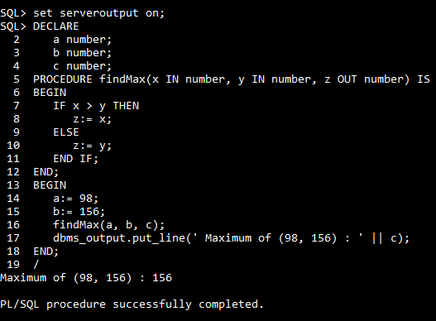

1. Computes the cube of value of a passed value using procedure.

Solution:

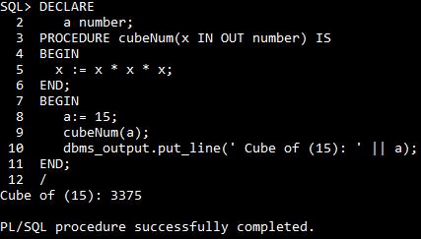

1. Create a PL/SQL Procedure Block to raise salary of employees working on user input project number by a user input amount; both inputs have to be passed to the procedure.

Solution:

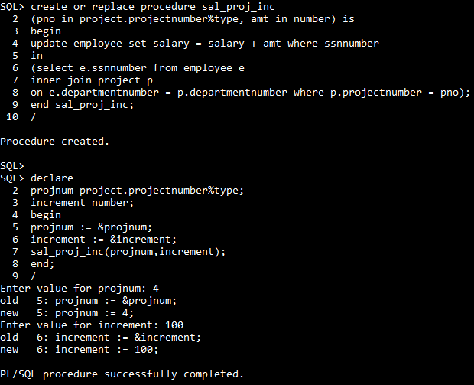

1. Create a trigger that fires and updates the price of product.

Solution:

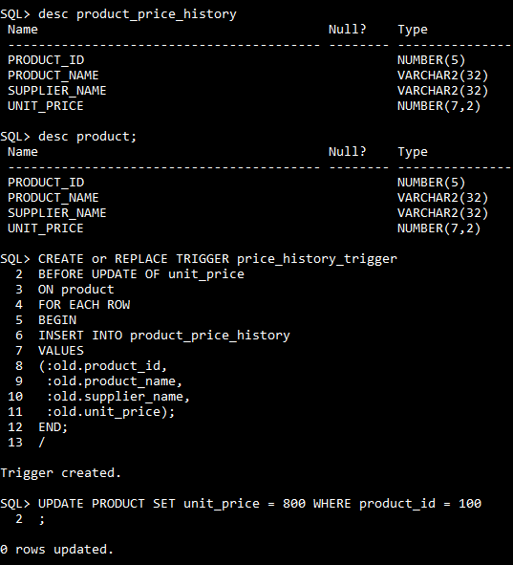

Note that if I ROLLBACK the transaction before committing to the database, the data inserted to the table is also rolled back.

1. Create a trigger for update the salary in employee table.

Solution:

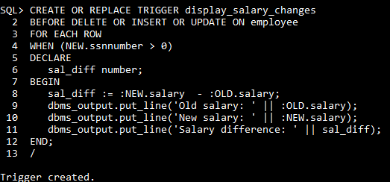

Triggering a trigger display_salary_changes:

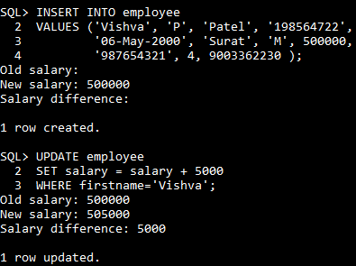

1. Write a PL/SQL block to change address of a particular employee by taking his/her employee number interactively.

Solution:

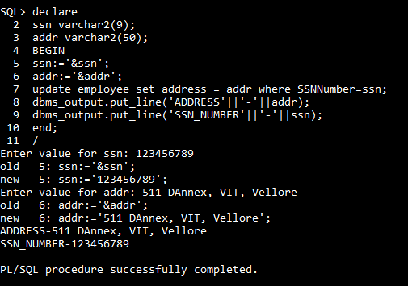



1. Write a PL/SQL block to display number of employees for each department.

Solution:

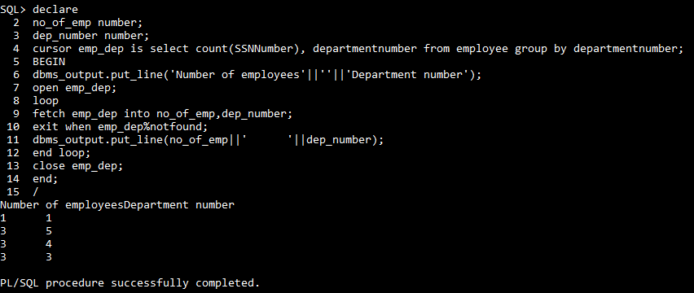

1. Create a PL/SQL Function Block to return the number of employees working more than user n hours a week, where n is an IN mode parameter.

Solution:

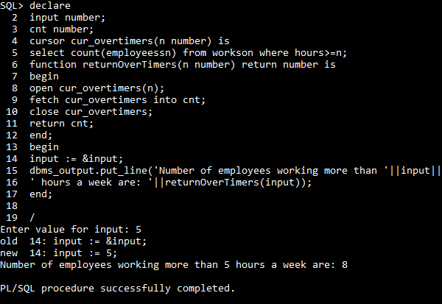

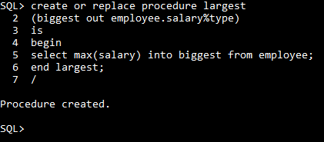

1. Write a PL/SQL block to display employees who are top three earners in the company.

Solution:

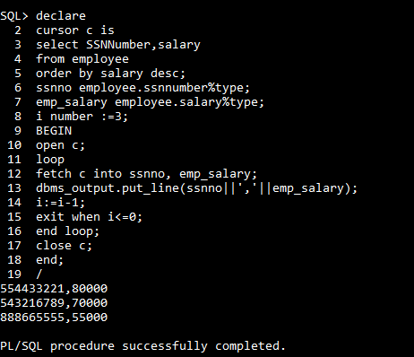

1. Using PL/SQL make a procedure to increase the salary of all employees by 10%.

Solution:

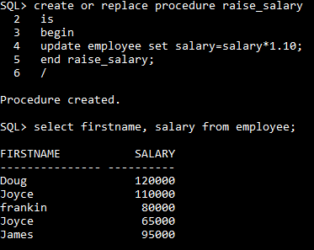

1. Write a PL/SQL block to find the greatest of three numbers.

Solution:

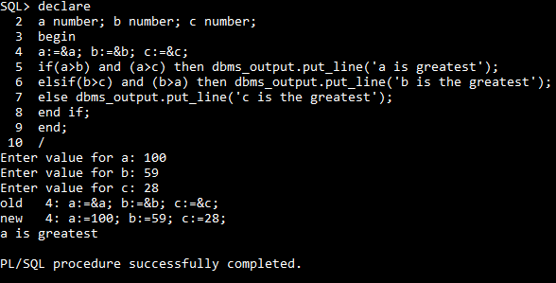

1. Find the maximum salary of employee using procedural call

Solution:

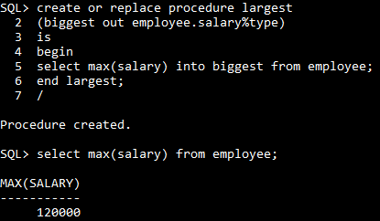

1. Create a procedure using PL/SQL to pass an Associative Array to Standalone Subprogram

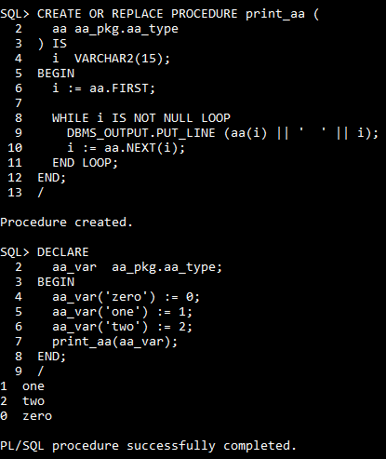

1. Create a PL/SQL Procedure Block to find the first n numbers in Fibonacci series, where n is passed as an IN-mode parameter.

Solution:

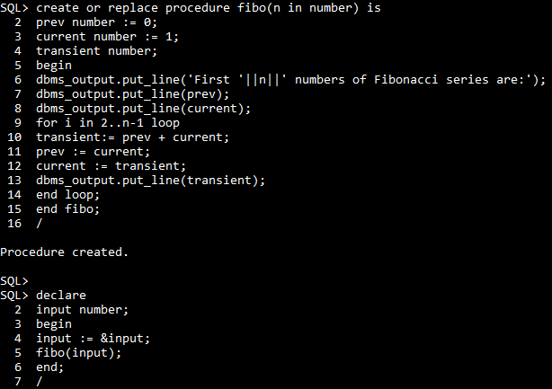

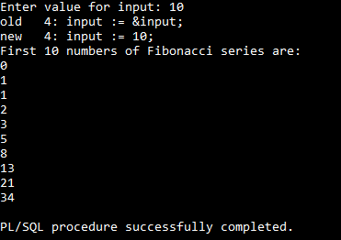

1. Write a procedure to accept an employee name and display his department details.

Solution:

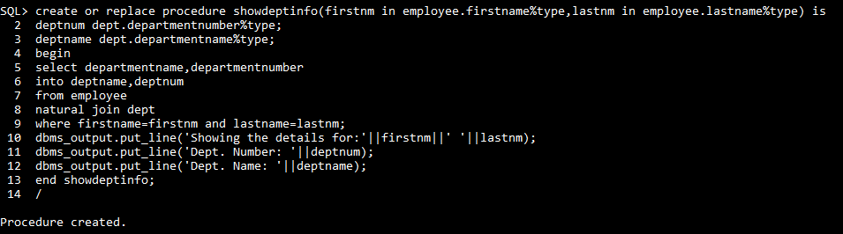

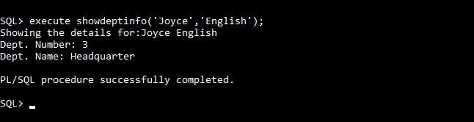

1. Using PL/SQL create a package to add department.

Solution:

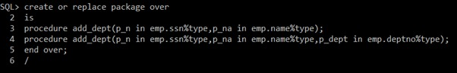



1. Create a trigger that protects the employee table from insert, delete and update queries.

Solution:

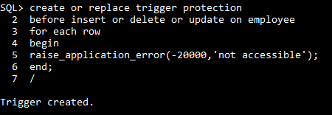

1. Create a procedure using PL/SQL to find sum of cube up to n numbers.



